**Question-1**

A system uses FIFO policy for page replacement. It has 4 page frames with no pages loaded to begin with. The system first accesses 50 distinct pages in some order and then accesses the same 50 pages in reverse order. How many page faults will occur?

1) 96

2) 100

3)  97

4) 92

**Answer**

Option 1 : 96

Page frames = 4

Pages: 1, 2, 3, 4 .... 45, 46, **47, 48, 49, 50,** 50(H), 49(H), 48(H), 47(H), 46, 45, .....4, 3, 2, 1.

First 50-page accesses will cause page faults but in reverse order page number 50, 49, 48, and 47 will not cause a page fault.

Hence total page faults are 50 + 46.

**Question-2**

A system uses FIFO policy for page replacement. It has 4 page frames with no pages loaded to begin with. The system first accesses 100 distinct pages in some order and then accesses the same 100 pages but now in the reverse order. How many page faults will occur?

1. 196
2. 192
3. 197
4. 195

**Answer**

Option 1 : 196

Given that page frame size = 4

As there are 100 distinct pages which are first accessed → 100 page faults

when it accesses the same 100 pages but now in the reverse order → (100-4).

Because page frame size is four.

Therefore, Total number of page faults = 100+ (100-4)= 196

**Question-3**

In which one of the following page replacement algorithms it is possible for the page fault rate to increase even when the number of allocated frames increases?

1. LRU (Least Recently Used)
2. OPT (Optimal Page Replacement)
3. MRU (Most Recently Used)
4. FIFO (First In First Out)

**Answer 4**

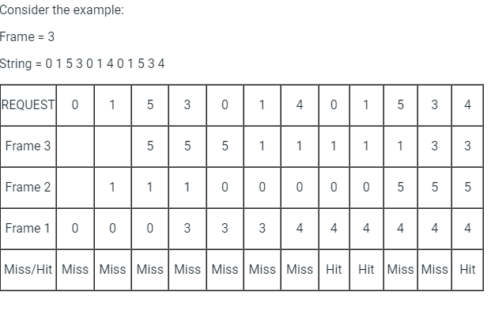

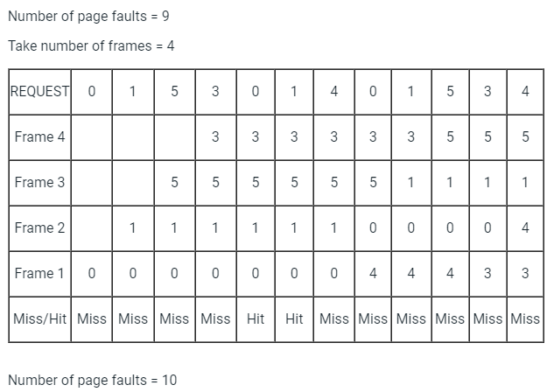

**Question-4**

Given reference to the following pages by a program

0, 9, 0, 1, 8, 1, 8, 7, 8, 7, 1, 2, 8, 2, 7, 8, 2, 3, 8, 3

How many page faults will occur if the program has three page frames available to it and uses an optimal replacement?

1. 7
2. 8
3. 9
4. None of the above

**Answer**

Option - 7

0, 9, 0, 1, 8, 1, 8, 7, 8, 7, 1, 2, 8, 2, 7, 8, 2, 3, 8, 3

F, F, H, F, F, H,H ,F,H, H, F,H, H,H, H,H, H,F, H, H

**Question -5**

Consider the virtual page reference string

1, 2, 3, 2, 4, 1, 3, 2, 4, 1

on a demand paged virtual memory system running on a computer system that has main memory size of 3 page frames which are initially empty. Let LRU, FIFO and OPTIMAL denote the number of page faults under the corresponding page replacement policy. Then

1. OPTIMAL < LRU < FIFO
2. OPTIMAL < FIFO < LRU
3. OPTIMAL = LRU
4. OPTIMAL = FIFO

The given virtual page reference string is 1, 2, 3, 2, 4, 1, 3, 2, 4, 1 and the main memory size is 3-page frames.

